[SFB-3927](https://jira.appservices.mitel.com/browse/SFB-3927) – Case Notification QA/UAT:

Scenario-1:

1. Log in as “Karthik Jagadeesh” ([Technical Support](https://mitel--staging.my.salesforce.com/00e0P000000S3u0)). comment on existing case and save it.

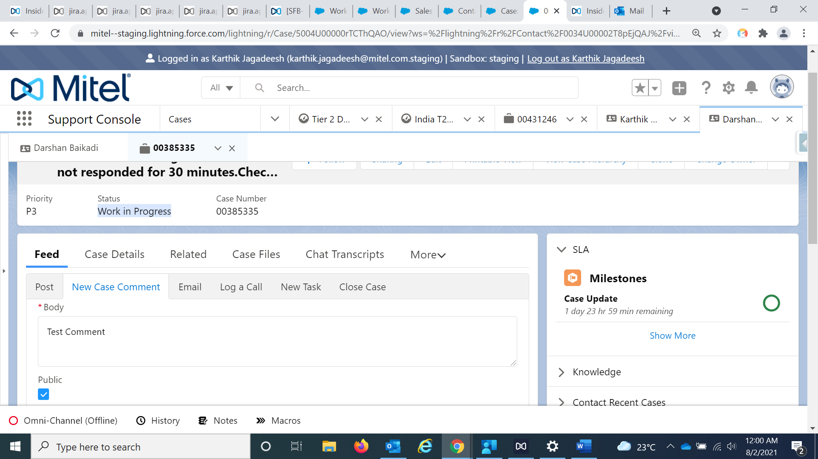

1. Updated case status to “customer Updated” and received email notification to case owner

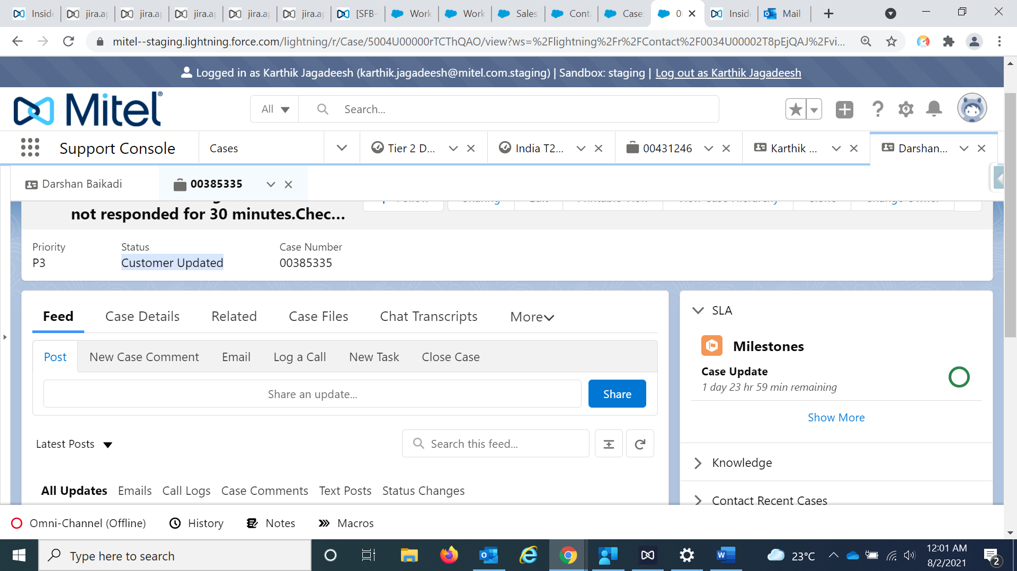

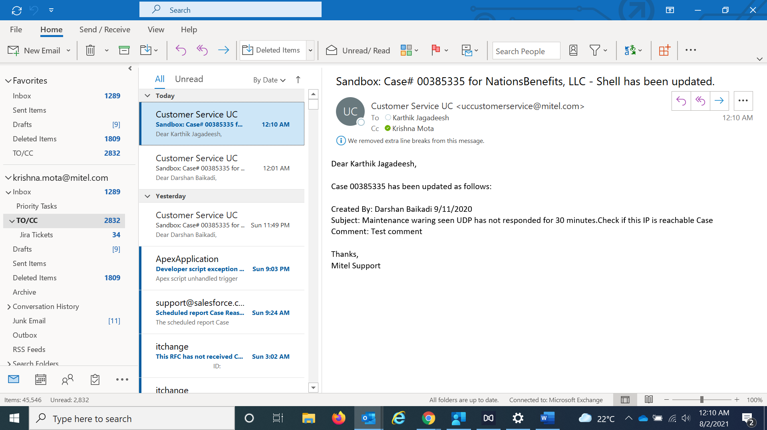

TEST RESULT: PASSED

Scenario- 2:

No Email notification when the case owner is set to “Queue”

1. Login as “[**Karthik Jagadeesh**](https://mitel--staging.my.salesforce.com/0050P000009Hm4h)” and change the owner to queue “UC Customer Service Email Cases” along with status to “work in progress” and save it.

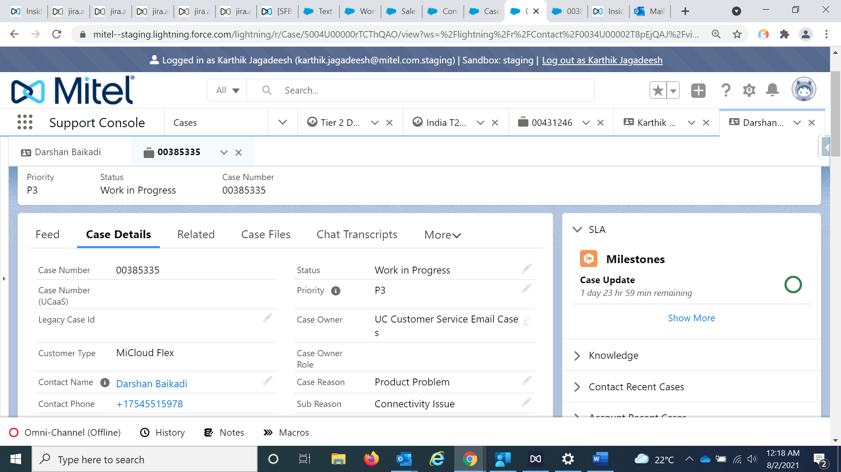

1. No email notification sent to queue and customer status is not set to “customer updated”

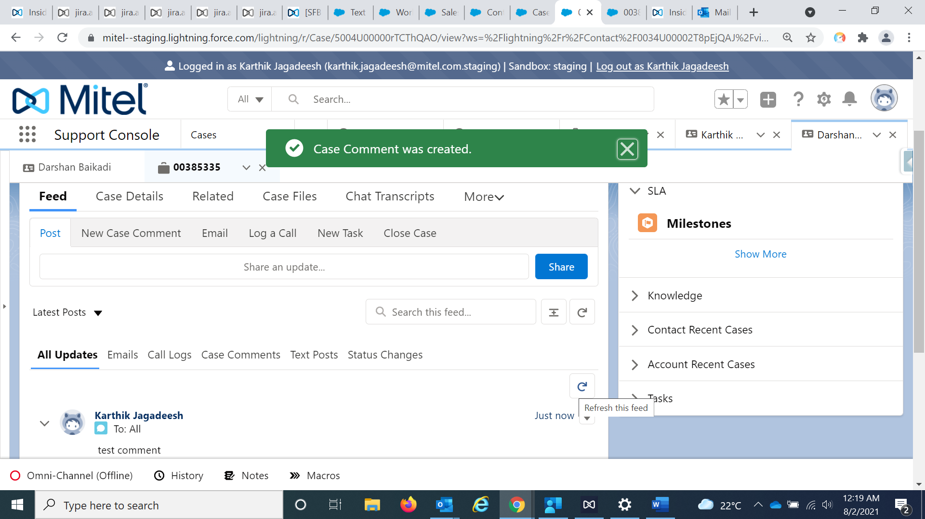

Note: To capture test results, added myself ( [krishna.mota@mitel.com](mailto:krishna.mota@mitel.com)) to additional emails in the workflow rule.

WF Rule: Notification to be sent out when Email is attached

1. Login as “Erik Korstad” ("Technical Support Manager")and upload case file and save it as shown below

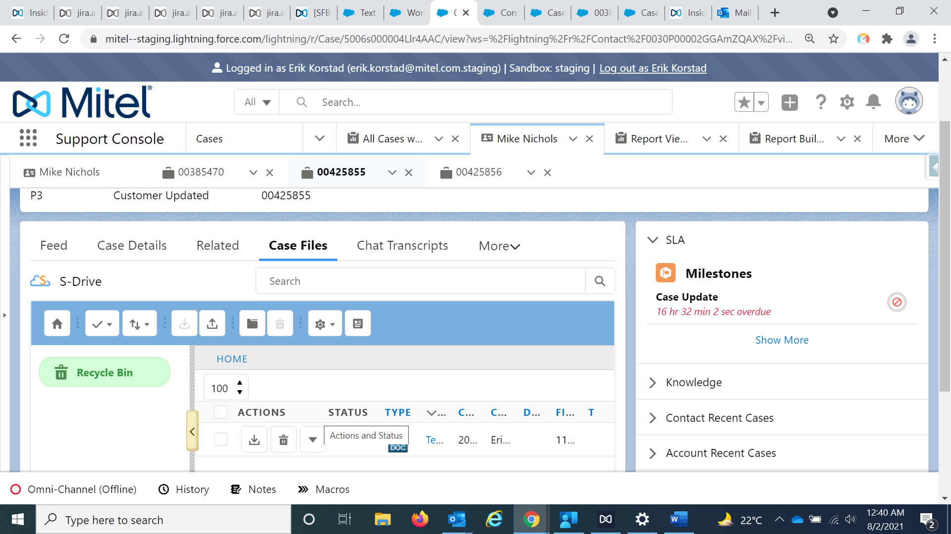

1. Case file update received

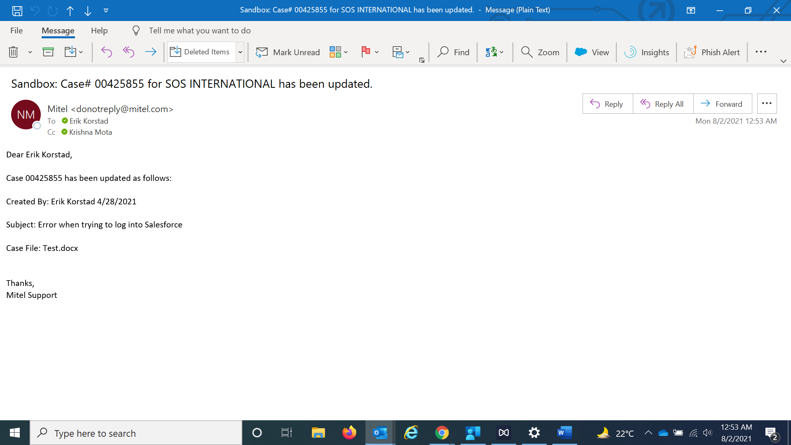

TEST RESULT: PASSED